from: Matthew Ehret <matthewehret@substack.com>
reply-to: Matthew Ehret <reply+2brjfn&doii8&&1289363ebde672b4ebb71aeb02e26d170545c5d655bbc73e6d107df15a901e79@mg1.substack.com>
to: fchase@gmail.com
date: Jan 15, 2024, 6:26 AM
subject: For Martin Luther King Day, Let us End his 2nd Assassination
mailing list: matthewehret@substack.com Filter messages from this mailing list
mailed-by: mg1.substack.com
signed-by: mg1.substack.com
View in browser

For Martin Luther King Day: Let us End his 2nd Assassination
MATTHEW EHRET

JAN 15
, 2024

Martin Luther King Jr. day has been celebrated every January 15 since it was a made a national holiday through the tireless efforts of Martin’s widow Coretta in 1983.
While many people take the opportunity to treat Martin’s life as a pre-packaged hallmark card of cliché speeches, far too few take the time to fully appreciate not only the depth of his philosophy, and understanding of the multifaceted evils plaguing society but also his brilliant plans, methods and vision for creative problem solving which touched on far more than the single issue of “civil rights” for which he is celebrated.
In fact, on deeper inspection, we should not be surprised to discover that Martin had come to bridge the gulf between
- racial justice,
- economic justice,
- imperial wars abroad and also
- global economic imperialism
and worked hard to create a functional battle plan to solve all of those problems.
It should thus not be surprising that this great leader was killed (followed soon thereafter by his ally Robert Kennedy) before his plans could be put firmly into motion, and the world took a very dark and un-natural trajectory. It should also not be surprising that many years after his death, efforts were put into motion by those unsatisfied with the death of his body- who wished nothing less than the assassination of his memory and legacy.

The 2nd Assassination of MLK
Over the past several years, a second assassination has been attempted decades after the life of Martin Luther King was cut short by a bullet on the balcony of the Loraine Motel on April 4, 1968. A story has gone viral across the international media which promises to shed light on the dark perversity of Martin Luther King Jr, and which has been loudly showcased in the 2023 book “King: A Life” by Jonathan Eig.
The scandal was featured in the June 2019 edition of Standpoint magazine by internationally renowned Martin Luther King “authority” David Garrow and aimed at destroying the myth of King as a moral leader of America by showcasing the ugliness of King’s true self as an orgy-loving abuser who had over 40 affairs and laughed as a friend raped a parishioner. Garrow states that his expose “poses so fundamental a challenge to his historical stature as to require the most complete and extensive historical review possible.”
The fact that so many news outlets jumped on the bandwagon should cause one to wonder why is this happening at this moment in history? Could this strange hysteria over a mediocre slander piece have anything to do with the fact that the polarized cages of left and right are finally breaking down? Could it be that the light shed upon the injustices corruption at the heart of the US government has awoken something within the collective psyche of Americans which many had thought long dead?
The timing is especially strange since the supposed “ground breaking evidence” which the heroic Garrow is bringing to light was actually first made public in November 2017, and on closer inspection, it wouldn’t qualify by any lawyer’s standard as “evidence”.

The “Scandal” Being Exposed
In November 2017, a batch of 19,000 formerly classified government documents, and wiretap transcripts relating to the assassination of John F. Kennedy were made public as per the JFK Records Collection Act of 1992.
Although nothing very dramatic was found among that otherwise highly redacted bundle, a strange 20 page FBI report on Martin Luther King Jr did cause some to take notice. In this report published weeks before his murder, an anonymous FBI agent records his assessment that MLK was a paid and loyal member of the Communist Party who had his speeches approved by Communist controllers. Not only that, but the report paints King as a sexual deviant of the highest order.
In the last two pages, the report explains how King engaged in a “two day drunken sex orgy in Washington D.C., Many of those present engaged in sexual acts, natural as well as un-natural, for the entertainment of onlookers. When one of the females shied away from engaging in an unnatural act, King and other males present discussed how she was to be taught and initiated in this respect”.
The conspicuous quality of this FBI report, is that it is so reminiscent of Christopher Steele’s 30 page “dodgy dossier” which justified FBI surveillance on President Trump in the lead up to the 2016 elections. Without ever taking a moment to prove any of its claims, the Steele dossier asserted dozens of instances of Trump’s sexual perversity and his adherence to the nefarious agenda of the Kremlin.
Similarly ignoring all actual evidence, the 1968 FBI report advances an image of King as a degenerate using only hearsay, conjecture, and third hand reports.
For example, the FBI, not known for their honesty, are convinced that King fathered a child with a mistress in Los Angeles purely because they were informed by “a very responsible Los Angeles individual in a position to know”.
The audio tapes, if they exist at all, have never actually been heard by anyone and we are told will supposedly be made public in 2027. One of the few people who was privy to the tapes was King’s wife Coretta who denied their validity to her last days asserting that the static recording did not feature her husband’s voice.

Garrow’s Sleight of Hand
Before going further, it is worth taking a moment to ask who is this David Garrow who has found the courage to reveal the “true Martin Luther King”?
Garrow is celebrated by the Mainstream Press as an international authority on Martin Luther King due largely to his Pulitzer Prize winning 1986 book “Bearing the Cross” which has somehow given him the authority to be the last word on the narrative of King’s life for the next 33 years.
Since that book Garrow has worked as a professor of history at various universities has found himself writing for proven CIA-sponsored mainstream rags such as the Washington Post, NY Times, Financial Times, New Republic and has more recently been stationed in England as a senior research Fellow at Cambridge University from 2005-2011. Today Garrow has become the official biographer of Barack Obama, and also an authority on the fraud of Russia-Gate attracting hordes of Trump supporters to his analysis and broader view of history.
Garrow has also made himself an enemy of the King family by leading slander campaigns against the late Coretta Scott King and her children who have managed the King Family Estate by labelling them as corrupt conspiracy theorists due to the family’s crazy belief that the government had anything to do with King’s assassination.

The Forgotten 1999 Civil Court Case
Garrow was first deployed to attack the family in the wake of the Memphis Civil Court trial in December 1999 wherein a four week long hearing of 70 witnesses ended with a Jury unanimously concluding not only that James Earl Ray (who had died in prison the year earlier) was innocent of the murder of Dr. King, but that the FBI and highest echelons of government conspired in the assassination.
During a press conference Coretta Scott King said:
“There is abundant evidence of a major high level conspiracy in the assassination of my husband, Martin Luther King, Jr. And the civil court’s unanimous verdict has validated our belief. I wholeheartedly applaud the verdict of the jury and I feel that justice has been well served in their deliberations. This verdict is not only a great victory for my family, but also a great victory for America. It is a great victory for truth itself. It is important to know that this was a SWIFT verdict, delivered after about an hour of jury deliberation.”
Coretta’s son Dexter (who is now the president of the King Center) spoke after his mother saying:
“We can say that because of the evidence and information obtained in Memphis we believe that this case is over. This is a period in the chapter. We constantly hear reports, which trouble me, that this verdict creates more questions than answers. That is totally false. Anyone who sat in on almost four weeks of testimony, with over seventy witnesses, credible witnesses I might add, from several judges to other very credible witnesses, would know that the truth is here.”
While a fuller expose documenting the FBI/Anglo-Canadian intelligence behind the King assassination will be documented elsewhere, it is sufficient to note for now that during this period of constant O.J. Simpson trial coverage across all press agencies, hardly a word on these hearings was covered by the media.
David Garrow stepped into the mud early on to slander the family and the court case as a whole saying of the family
“The King youngsters are part of a larger population of American people who need to believe that the assassination of a King or a Kennedy must be the work of mightier forces… Individuals need to see something of a harmony amongst impact and cause. That if something has a large evil effect, it ought to be the result of a huge evil cause”.
By denying the existence of causality, or conspiracy in regards to historical processes, this “world renowned historian” essentially admitted that he is either extremely dumb or a part of the conspiracy himself.
Exhibiting the height of hypocrisy, Garrow said of King’s children in 2009
“I fear we are at the point where the behaviour of the children is doing lasting, indelible damage to King’s reputation”.
Philip Madison Jones, a Hollywood producer and best friend of Dexter King has stated that Garrow’s anti-King family malice is due to the fact that King’s late wife Coretta Scott King refused to put Garrow in charge of a project involving King’s papers. Apparently, Garrow wished to do to King what Edgar Poe’s “official” biography Rufus Griswold did in 1850 [1].

Obama as a Superior Role Model
It was while working in Cambridge in 2008 that Garrow became obsessed with Barack Obama and with the idea of writing an untouchable biography that would render all other biographies obsolete for all time. This work was so magnificent and all-encompassing that it would require 9 years to write and would finally put an end to all speculation about Obama’s birth and shady life before politics. The effect of this work was a 1500 page fluff piece called “Rising Star: The Making of Barack Obama”.
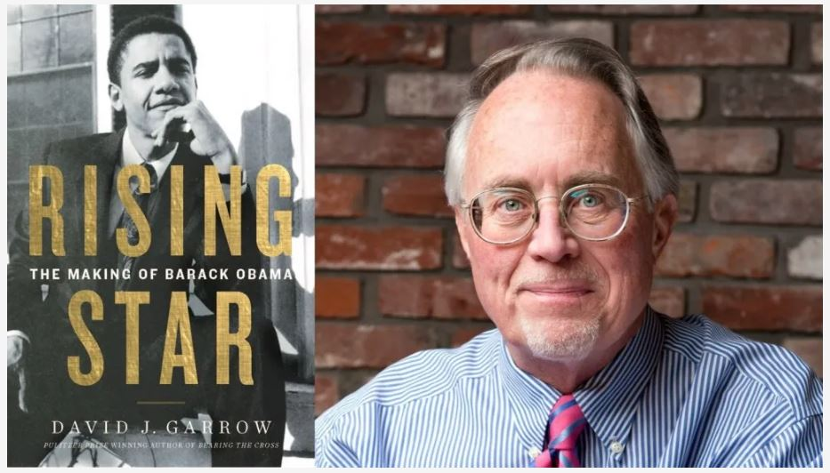
Describing his motive for writing his book Garrow said:
“My very purposeful intent with this book has been to produce a book of record that folks will still be using and relying upon 25, 35 years from now. All throughout 2008, I was disappointed by the quality and depth of journalism about his earlier life. I thought the mainstream media was being insufficiently curious about him and on the other hand, we simultaneously had all of these whacky oppositional actions out there regarding where was he born was he really a Muslim? And so I came to this really with a professional belief that someone with my background and experience should really tackle this.”
When asked in an interview how he managed to have so many long meetings with Obama in the White House (who apparently took the time out of his busy schedule to read the entire opus), Garrow stated that it was arranged by his personal friend Bob Bauer who just so happened to be Obama’s personal attorney. Amongst other crimes, Bauer had been known for providing the “legal justification” for Obama and Hillary Clinton’s unconstitutional bombing of Libya in 2011.
Both Bauer and Garrow have played a gang-counter-gang operation during Trump’s presidency, with Bauer acting as a loud voice for impeachment and advocate of the Russia-Gate narrative and Garrow playing an anti-Russiagate liberal socialist who has appeared on Fox News regularly as he is a rare case of a liberal intellectual attacking Russia-Gate.
While promoting the neo-liberal order embodied by Barack Obama on the one hand, Garrow has somehow managed to walk the fine line of convincing both left and right ideologues that he is trustworthy because his lofty intellect transcends partisanship.
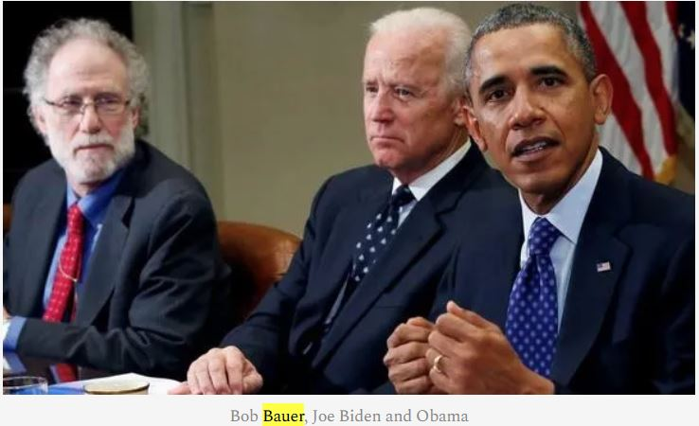
Bob Bauer, Joe Biden and Obama
Garrow has gained the respect of weak minded liberals and conservatives alike by criticising the abuses of the FBI while actually hiding the larger historical truths which Garrow’s masters wish to bury. In the case of the King story, Garrow appears critical of the FBI’s surveillance of King but then explains at length why their reasoning was completely logical and evidence based.
In a lengthy article, Garrow attempts to make the case that King’s close advisor Stanley Levison was a former financier for the Communist Party of America (CPUSA).
How did the FBI know that? He merely asked two former CPUSA members/FBI informant siblings Jack and Morris Childs who said so. Garrow wrote of this “irrefutable” evidence in a 2002 article in the Atlantic: “The Childs brothers’ direct, personal contact with Levison from the mid-1940s to 1956 was sufficient to leave no doubt whatsovever that their reports about his role was accurate and truthful”. Levison’s connection to King provided Hoover with the “legal grounds” to begin wiretapping King in 1955.
While the evidence used by Hoover to justify wiretaps were nearly always untrue, what has come to light in recent years is that much of the CPUSA [Communist Party of the USA] as well as the black nationalist movements were under total control of the FBI with vast numbers of the membership of both organizations on the roster as paid informants. After King’s assassination, the Childs brothers, still under FBI direction, rose to the highest echelons of the communist party and were selected to arrange for money transfers from the Kremlin to the CPUSA.
In 1956, Hoover created COINTELPRO with the explicit purpose of infiltrating and subverting civil rights movements; utilizing informants, false narratives and low intensity psychological warfare.
Hoover himself said of the operation “The purpose of this new counterintelligence endeavor is to expose, disrupt, misdirect, discredit or otherwise neutralize the activities of black nationalist, hate type organizations and groupings, their leadership, spokesmen, membership and supporters.”
Fearing the rise of moral leadership as a destruction of the “rules of the game” which the FBI wished to control from above Hoover said that they must “prevent the rise of a ‘messiah’ who could unify and electrify the militant black nationalist movement”.
After an important 1963 march on Washington for jobs and freedom led by King, FBI assistant director (and the man in charge of COINTEL PRO wrote to Hoover saying: “We must mark him now if we have not done so before, as the most dangerous Negro of the future in this nation from the standpoint of communism, the Negro, and national security.”
Within Months, the FBI had begun to threaten King with the release of faked transcripts painting him as a deviant to the public unless he stopped his activism going so far as to suggest he commit suicide in order to save his honor. 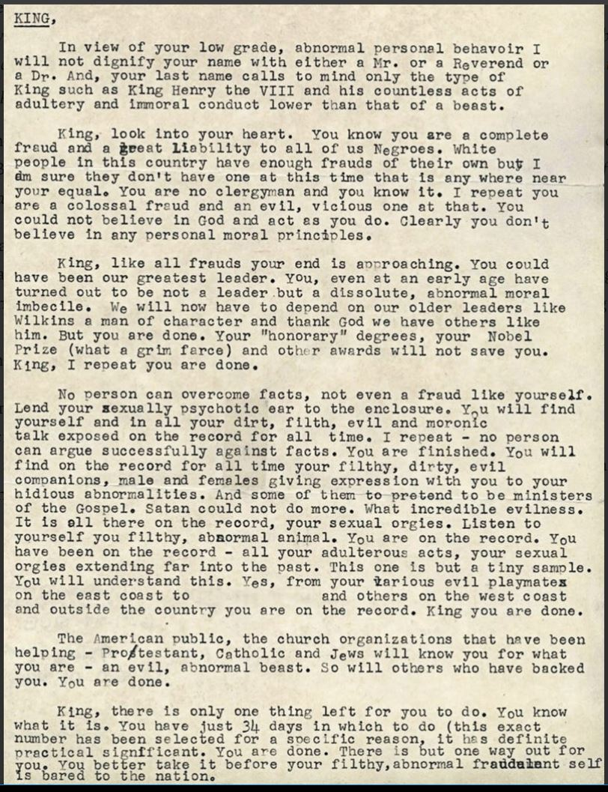.

JFK, Hoover and RFK
While Garrow writes extensively that Bobby Kennedy acting as Attorney General was to blame for King’s illegal surveillance, the reality is quite the reverse. Both Kennedy brothers detested the FBI’s dictatorship in America and both understood the international power structures of British Intelligence shaping the CIA/FBI behavior from above. When JFK fired Allan Dulles, he made many maneuvers to bring the FBI under control to little avail. The night that John was killed, Bobby Kennedy was with his close friend Congressman Cornelius Gallagher who later reported that Bobby stated that “the old man (Hoover)” was behind it.
Gallagher went on record in a 2013 interview saying “if there was a conspiracy then only Hoover and his special group could have killed the President”.
Recent research has found JFK’s assassination to have been coordinated by the Permindex assassination bureau which New Orleans Attorney General Jim Garrison had uncovered during his investigation of JFK’s assassination [2].
While Bobby is painted as an anti-MLK enforcer for the FBI by Garrow, the reality is that Bobby personally intervened to get King out of a six month sentence in a maximum security penitentiary, for having an invalid driver’s license, in 1960. As he was deciding to run for President in 1968, MLK was simultaneously contemplating running as a candidate which would have brought these two collaborators into a potentially powerful political alliance. Ironically, FBI Director James Comey (who was later fired for attempting his “Hoover moment” with incoming President Trump), slandered Bobby in a London Guardian 2015 interview saying“I keep Bobby’s authorization of King’s FBI surveillance on my desk to remind me of the agency’s past misdeeds”.
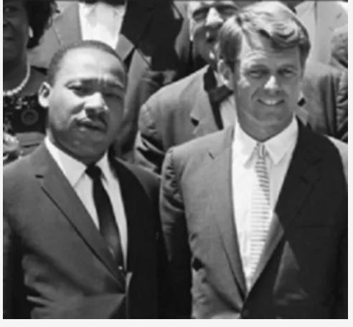
Unfortunately, the beautiful possibility of a 1968 Bobby Kennedy/Martin Luther King alliance was not permitted to come into being and an era of insanity was unleashed. While such operations as MK Ultra and COINTELPRO came to formal ends in the 1970s, their operations continued on as the Deep State embedded itself ever more deeply into the heart of America’s soul.

Where do We go from Here?
We stand at a moment which is shaped by a great hope for a new set of relationships based on the potential alliance between western and Eastern nations under a guiding principle of win-win cooperation, let us remember the words of Martin Luther King Jr in his August 1967 speech titled “Where do We go from Here?”
“I want to say to you as I move to my conclusion, as we talk about “where do we go from here?” that we must honestly face the fact that the movement must address itself to the question of restructuring the whole of American society…
Now, don’t think you have me in a bind today. I’m not talking about communism. What I’m talking about is far beyond communism. …Communism forgets that life is individual. Capitalism forgets that life is social. And the kingdom of brotherhood is found neither in the thesis of communism nor the antithesis of capitalism, but in a higher synthesis. It is found in a higher synthesis that combines the truths of both. Now, when I say questioning the whole society, it means ultimately coming to see that the problem of racism, the problem of economic exploitation, and the problem of war are all tied together. These are the triple evils that are interrelated…
And I must confess, my friends, that the road ahead will not always be smooth. There will still be rocky places of frustration and meandering points of bewilderment. There will be inevitable setbacks here and there. And there will be those moments when the buoyancy of hope will be transformed into the fatigue of despair. Our dreams will sometimes be shattered and our ethereal hopes blasted. We may again, with tear-drenched eyes, have to stand before the bier of some courageous civil rights worker whose life will be snuffed out by the dastardly acts of bloodthirsty mobs. But difficult and painful as it is, we must walk on in the days ahead with an audacious faith in the future….
When our days become dreary with low-hovering clouds of despair, and when our nights become darker than a thousand midnights, let us remember that there is a creative force in this universe working to pull down the gigantic mountains of evil, a power that is able to make a way out of no way and transform dark yesterdays into bright tomorrows. Let us realize that the arc of the moral universe is long, but it bends toward justice.”
In his closing remarks to the 1999 jury trial that found King to be a victim of a vast conspiracy, Martin’s son Dexter King left a challenge to all who would come into contact with this news:
The question now is, “What will you do with that?” We as a family have done our part. We have carried this mantle for as long as we can carry it. We know what happened. It is on public record. The transcripts will be available; we will make them available on the Web at some point. Any serious researcher who wants to know what happened can find out.”

Footnotes
[1] The idea that Poe was a deviant, alcoholic and opium addict was entirely generated by the pen of Poe’s enemy Rufus Griswold who managed to purchase the entire body of Poe’s personal writings from the poet’s financially strained aunt and then proceeded to “lose everything” while publishing a biography that became the authoritative book on Poe for the next 170 years.
[2] Much of Garrison’s work was used in the crafting of Oliver Stone’s JFK whose buzz on Capitol Hill created the momentum for the passage of the JFK Records Declassification Act of 1992.

